## Product Design Specification: Motorized Pan & Tilt Camera Mount

#### Team 14: Abdullah Barghouti, Ammar Khan, Josh Davis, and Travis Hermant

**Concept of Operations**

The camera mount will rotate and tilt a lightweight camera or smartphone, convenient for video recording or live-streaming events. Rotation is controlled using an arrow key remote control. Designed to attach between a tripod and a camera or smartphone holder with standard ¼”-20 screws.

**Market Analysis**

The intended market is for home usage, particularly for streaming via small devices such as webcams and cell phones. Most of the market for similar camera mounts are for much larger DSLR cameras, with the price starting around $100 for one capable of maneuvering an entry-level DSLR camera, excluding power supply. Smaller, servo-based DIY kits are around $55 in price for just the brackets and servos, excluding controls and power supply. Our product is different in that it presents a more cost effective alternative for a smaller scope, with a pre-assembled all-inclusive package.

Based on the components used and overall design, our product could be sold for a total price of $35. Depending on the number of units manufactured, the price might vary due to the economy of scale. The price takes into account the cost of parts, materials, and research & development.

**Requirements**

Essential features (Must):

* Horizontal rotation for panning the camera
* Vertical tilt up and down from the level position
* Arrow key remote for controlling direction of rotation

Ideal features (Should):

* Maximum horizontal rotation between 120° and 180°
* Minimum vertical tilt ±15°, no more than ±45°
* Supports a 10 oz load (lightweight camera or smartphone)
* Include a 1/4”-20 screw for camera attachment
* Include 1/4”-20 threads underneath for tripod attachment
* Have rubbery surfaces on top and bottom for firm grip

Possible extended features (May):

* Adjustable speed of rotation settings
* Stores saved positions to automatically rotate into desired positions
* Smooth panning from one programmed position to another

**System Architecture and Design Specification**

* Processor: ATmega32U4RC-AU Microcontroller, operated at 5V with external 16MHz crystal oscillator, programmed with Arduino IDE
* Inputs: 4-Button arrow key remote connected to single digital I/O pins
* Outputs and actuators: 2 Servos will receive PWM signals from the MCU based off of buttons pressed; LEDs are used for testing purposes
* Power Supply: 5V 2A DC Power Supply

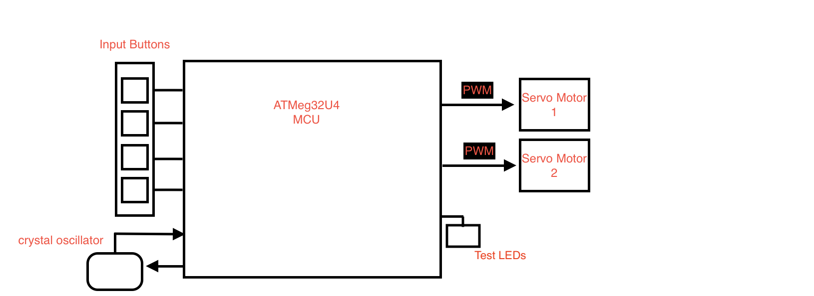

Component-wise, the device would use two servo motors (one for rotation and one for tilt), which have position control based on PWM duty cycles. A four-button arrow key (left, right, up, down) would provide directional inputs to the device which would tell it which way to rotate. The interface between the arrows and PWM value will be programmed in the Arduino IDE checking for voltage highs and lows to determine the output of the button. The motion will be controlled by taking one input at a time. The left and right arrows will be responsible for horizontal rotation, while the up and down arrows will be responsible for vertical rotation. Possible additional features would include speed settings such as slow/medium/fast for rotation.